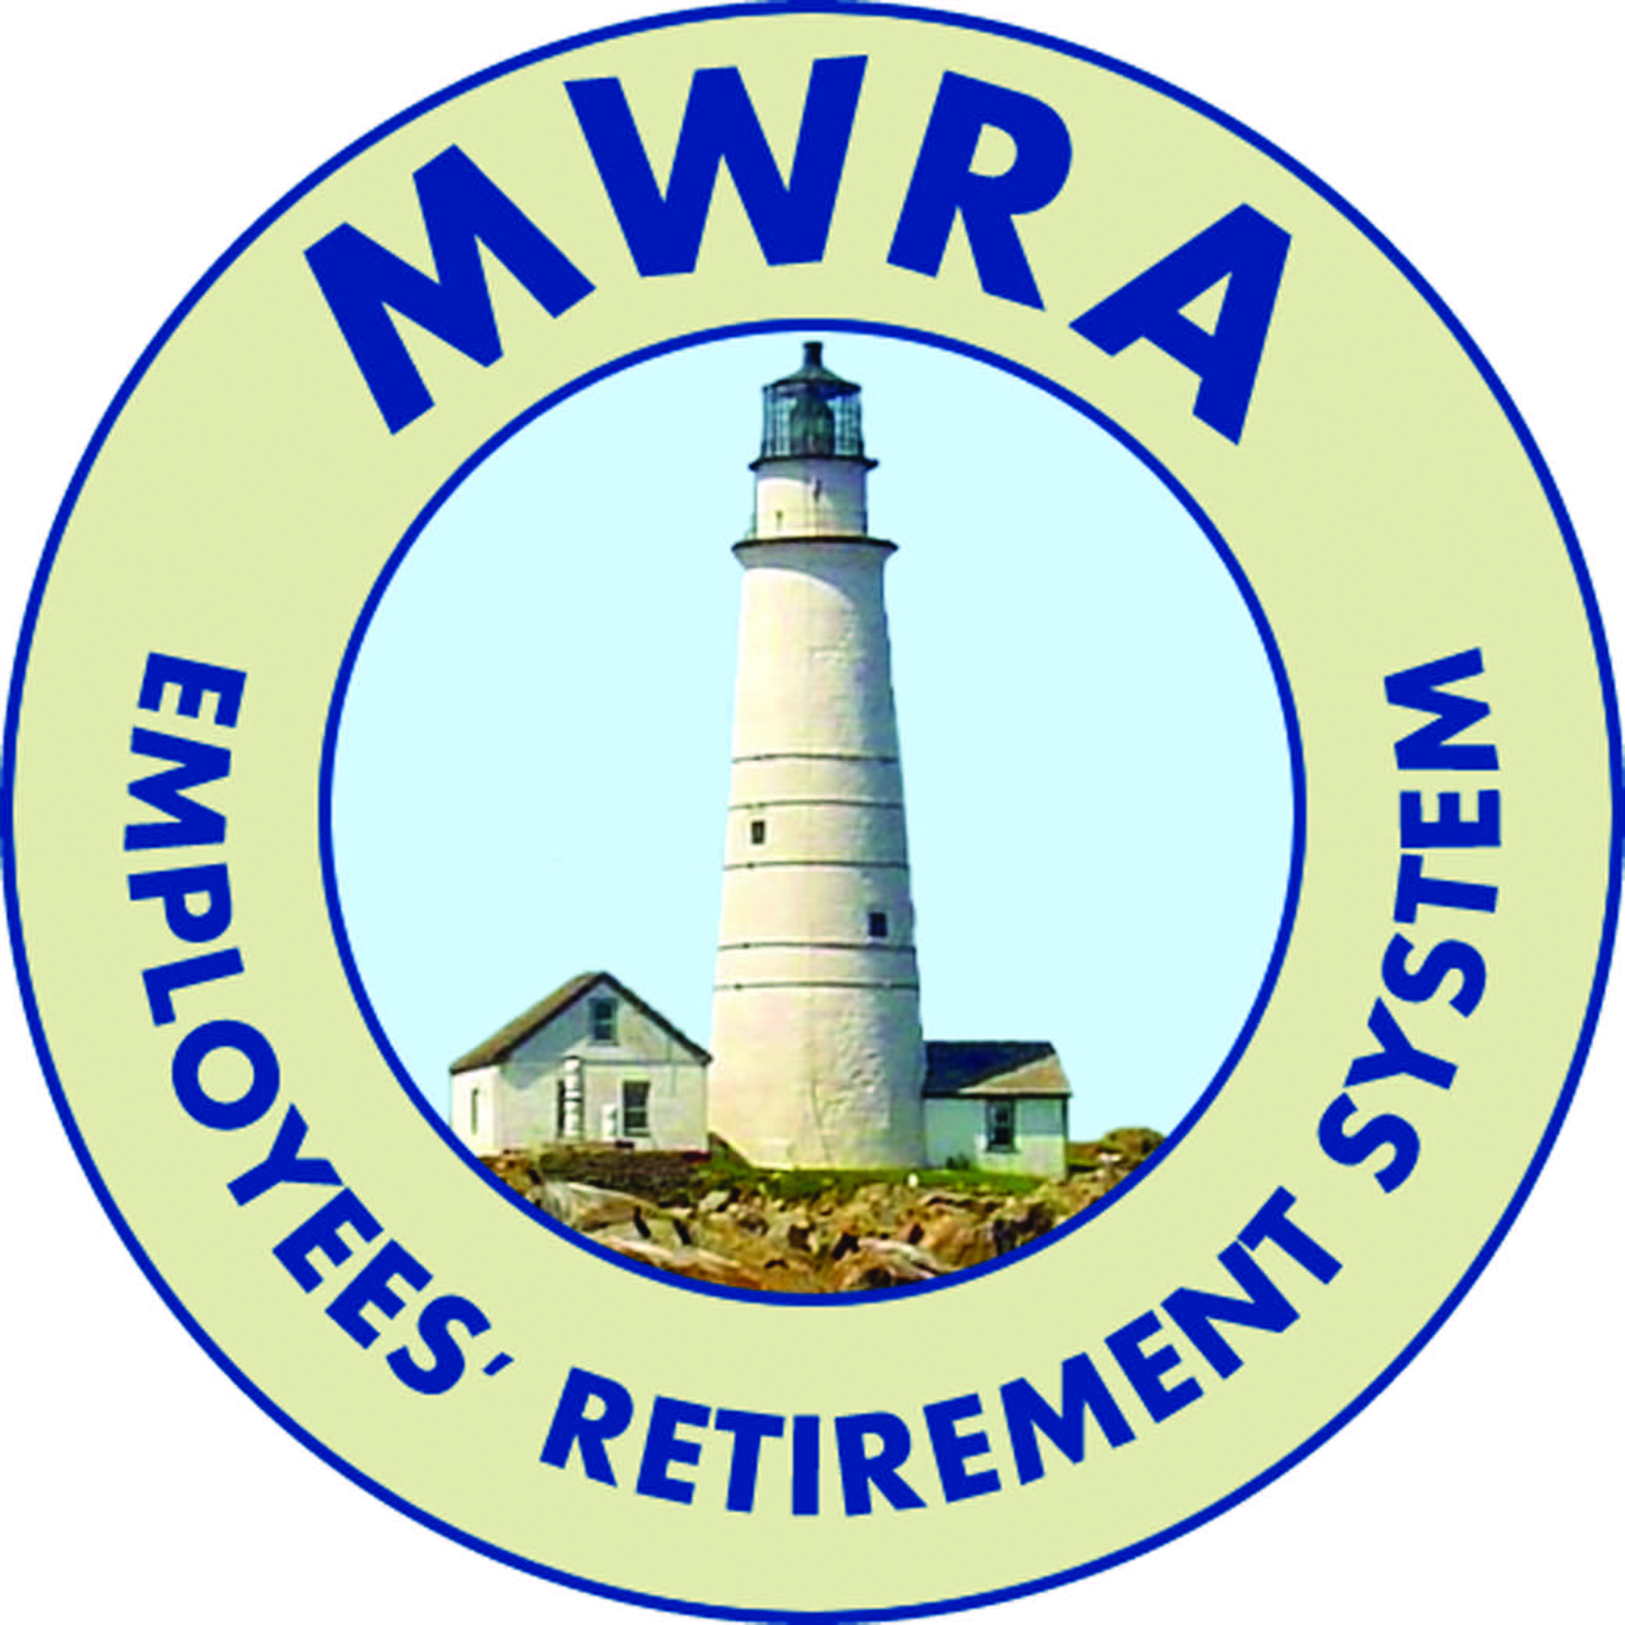
MWRA
Employees’ Retirement System
Since July 1, 1985

TO: Members and Retirees of the MWRA Employees’ Retirement System

FROM: Ellen K. Philbin, Election Officer

DATE: March 30, 2015

RE: NOTICE OF ELECTION

Election:
An election will be held on Tuesday, June 30, 2015 to fill one of the two elected positions on the MWRA Employees’ Retirement System’s Board. All ballots must be received by 12:00 NOON via U.S. Mail on Tuesday, June 20, 2015 at the MWRA Employees’ Retirement System’s office located at the MWRA facility, 2 Griffin Way, Chelsea, MA 02150.

Purpose:
To elect the First Elected Member of the MWRA Employees’ Retirement Board in accordance with the provisions of M.G.L. Chapter 32 and 840 CMR 7.00.

Term of Office:
A three-year term beginning on July 1, 2015 and running through June 30, 2018.

Candidates:
Any member-in-service or retiree of the MWRA Employees’ Retirement System are eligible to be a candidate.

Nomination Papers:
Any member or retiree of the MWRA Employees’ Retirement System may qualify as a candidate by filing, with the office of the MWRA Employees’ Retirement System, a nomination paper or papers containing both the signature and address of at least twenty (20) active members or retirees of the MWRA Employees’ Retirement System. Nomination papers may be obtained at the following:

MWRA Employees’ Retirement System, 2 Griffin Way, Chelsea, MA 02150

*** Note: Beneficiaries and Survivors are not eligible to participate. ***

The last date to submit nomination papers will be Friday, May 15, 2015 by 12:00 noon

